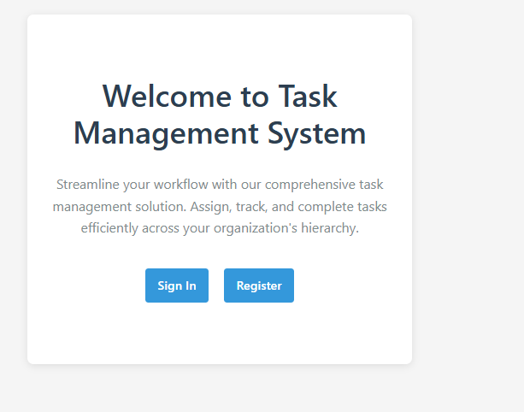  
This is the welcome page. You have two option.  
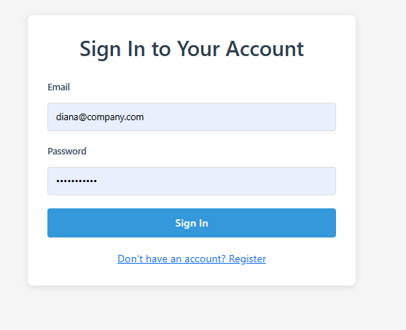  
If you click on Sign in then you have to put your correct user email and password.  
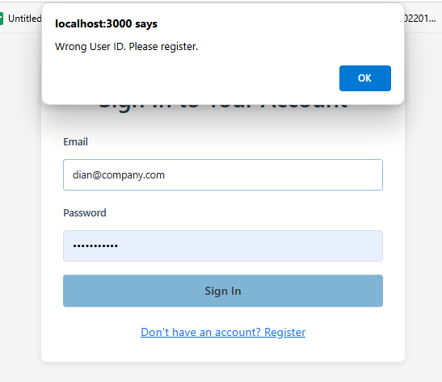  
If you put wrong email then it wont recognize you.   
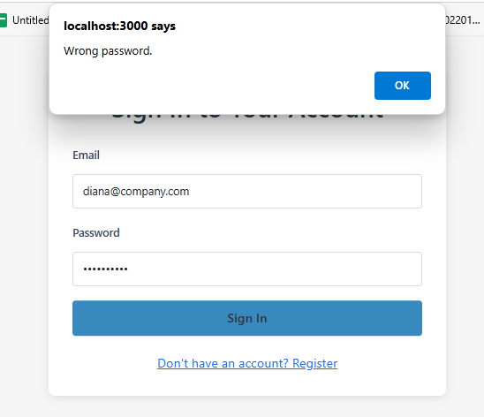If you put wrong password then it will not let you in either  
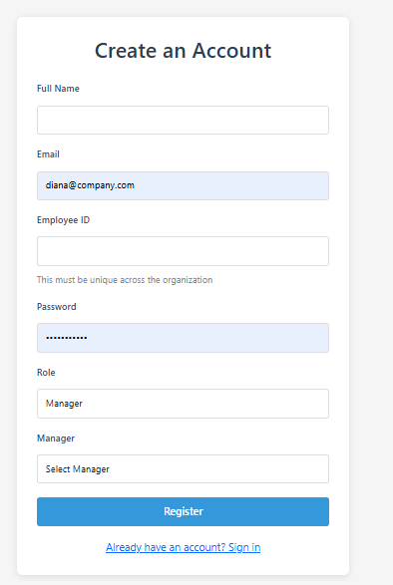  
This is register page. It will have the option of selecting manager, if your role is Manager and Employee.

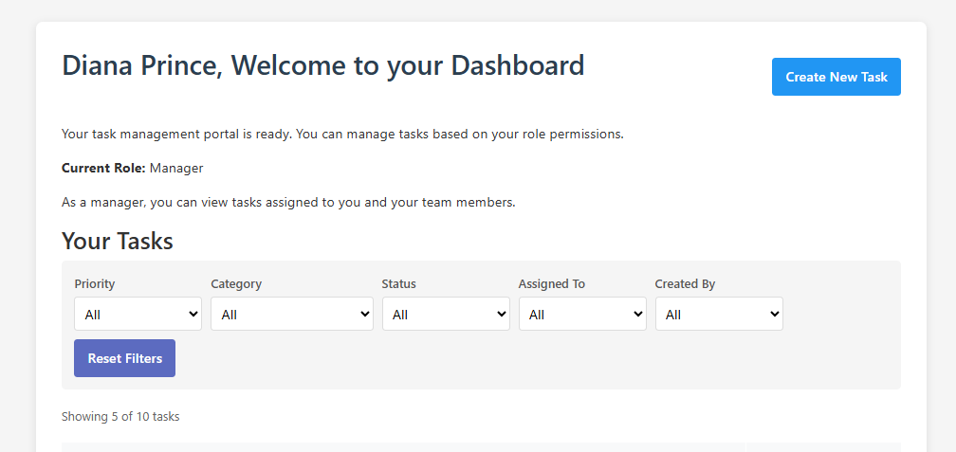  
You are in. Now you can sort your tasklist by the help of column headers. You can filter using these columns too  
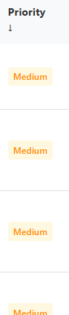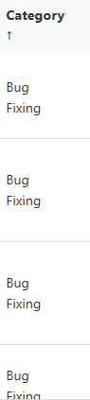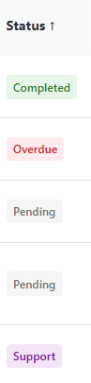  
You can Go to next pages using the button next page. You can Reset Filters by clicking on Reset Filters.  
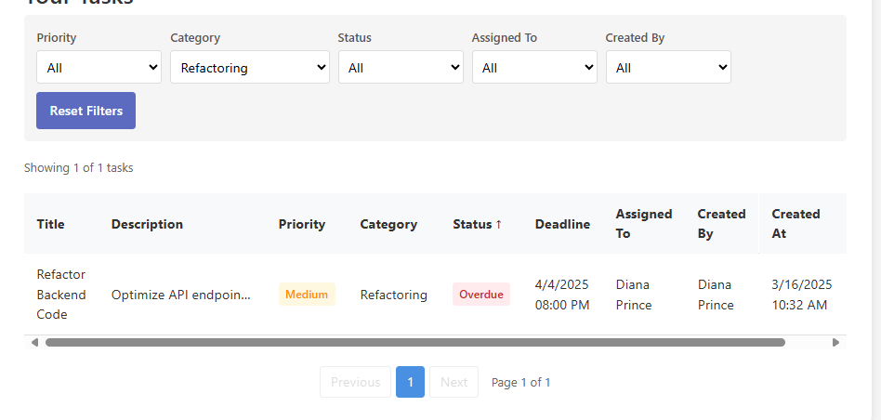  
If you click on second tab called Reports you can see the number of tasks by category.  
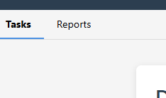  
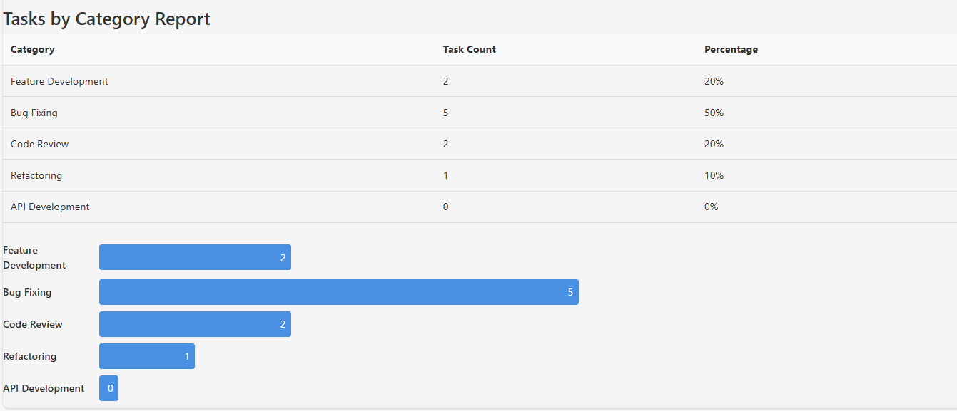  
There is a bar chart and percentage as well.  
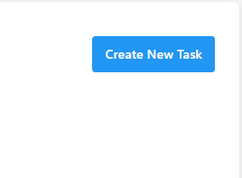When you click on Create New Task then you will be able to see the bottom window  
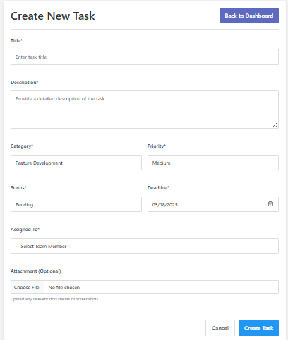If you are maanger you can assign tasks to your employees and yourself. If you are employee then you can assign tasks to yourself only.  
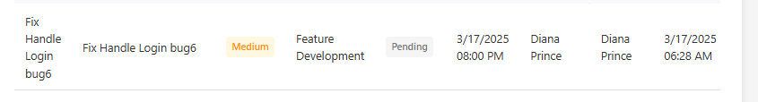  
To edit tasks you have to click on the rows.  
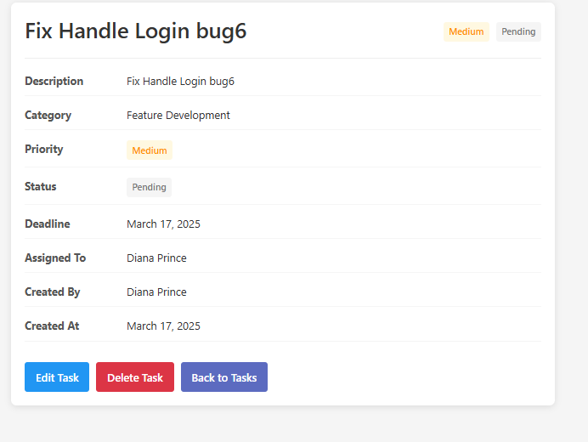  
It will open this window. Then you have three options. If you click Edit task then bottom window will open  
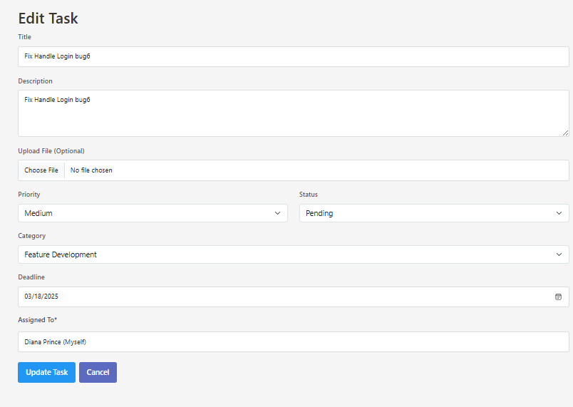  
You can edit the tasks by clicking on update task  
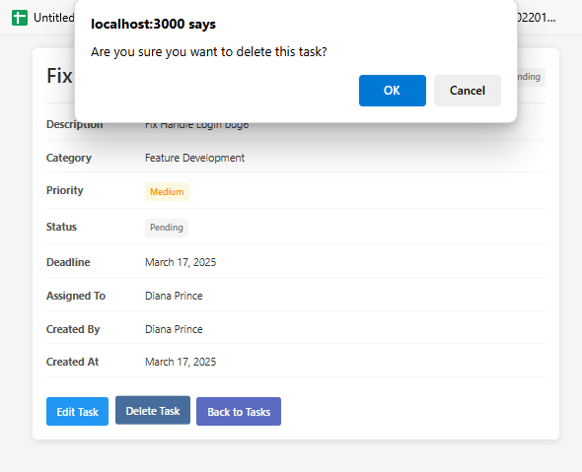  
If you click delete then you will be asked are you sure? Then if you click okay you can delete the task. You can also go back to Tasks. It will bring you to the dashboard.